**Lambda Bootstrapping**

1**Create Lambda Function to delete the unused EBS volume across regions**

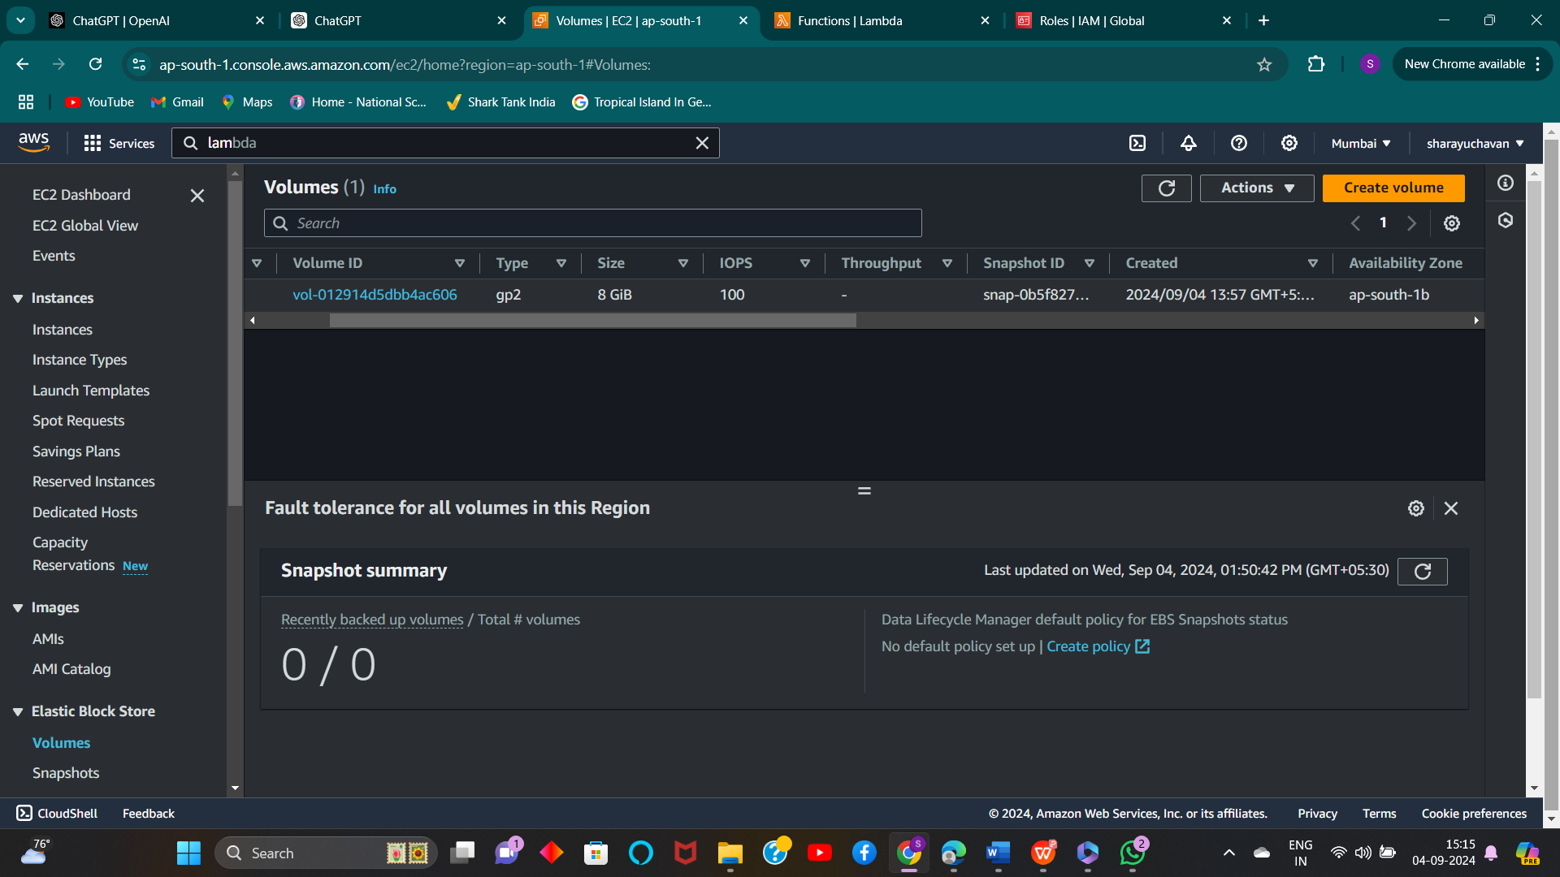**2) Crate Lambda function**

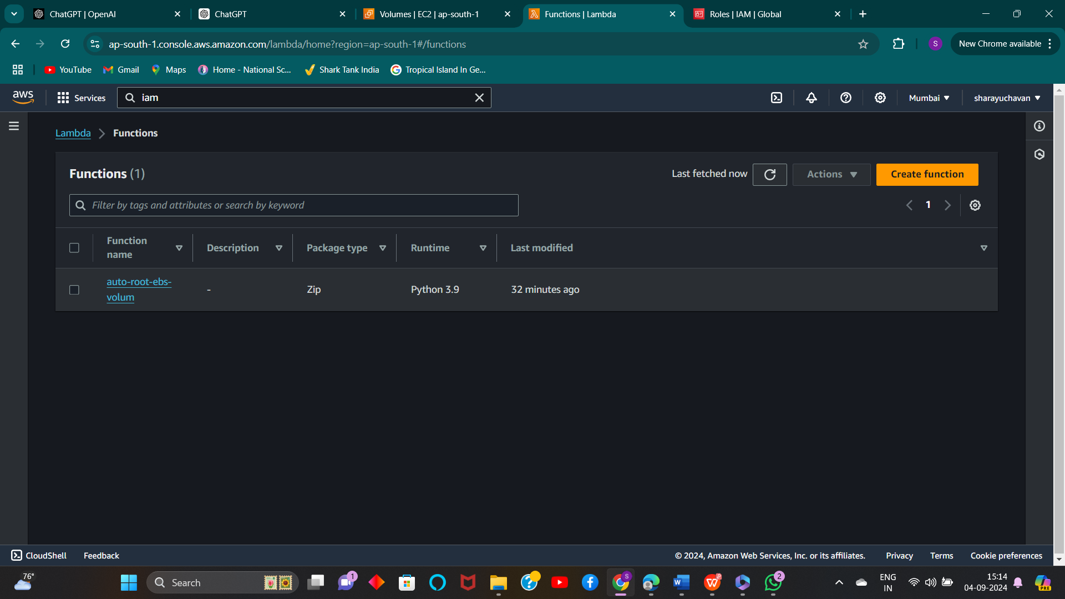

**3) ) Change lambda function name as lambda name + .py**

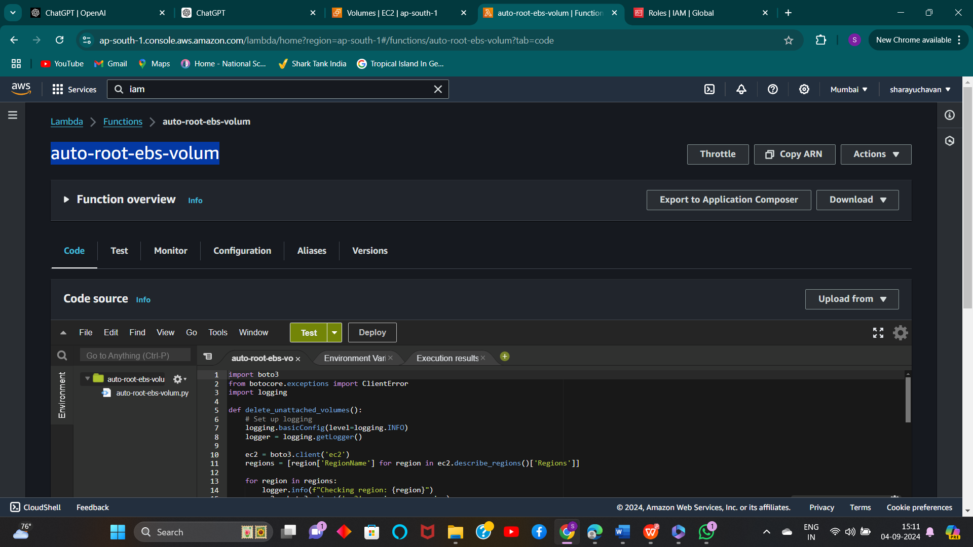

**4) Change runtime setting name as below**

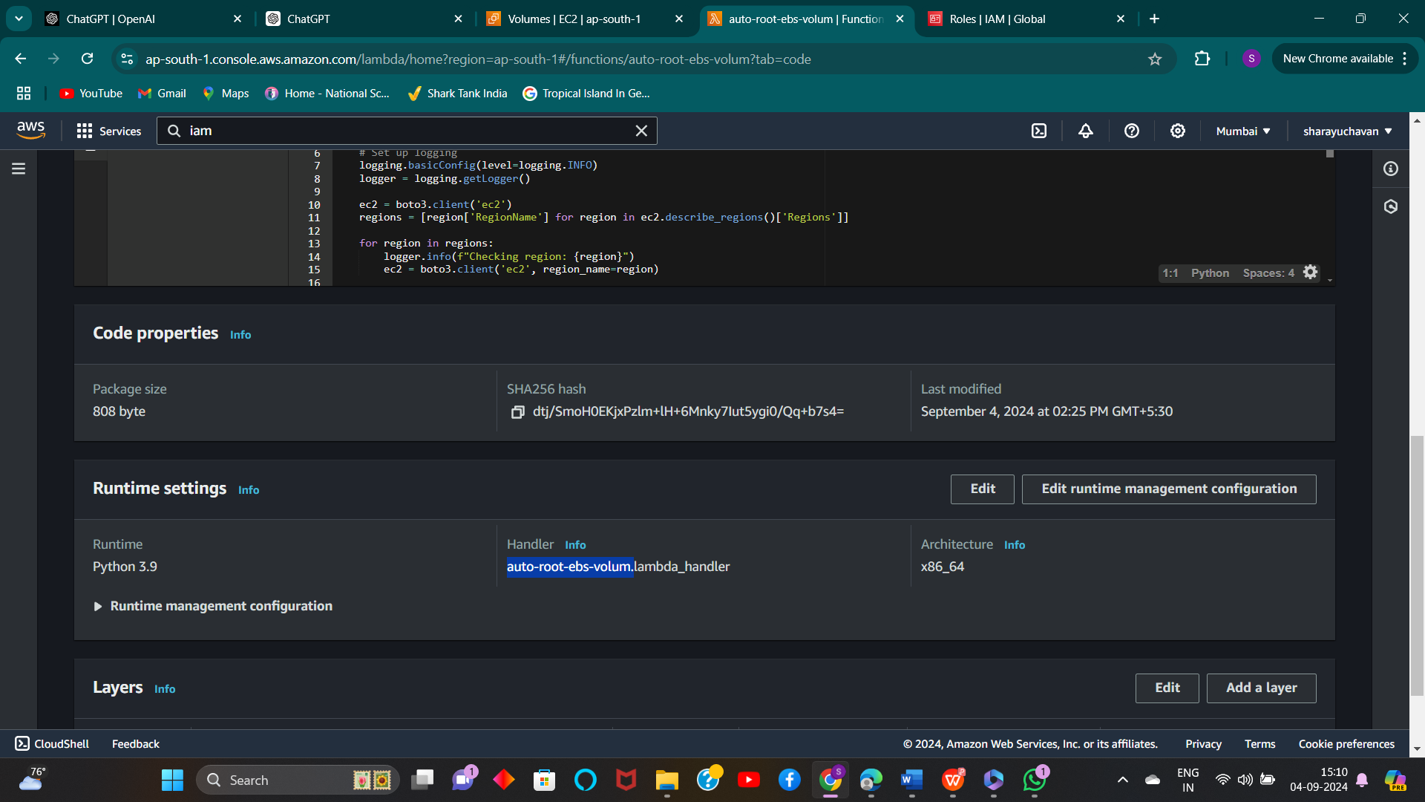

**5) Change timeout value to 1 min**

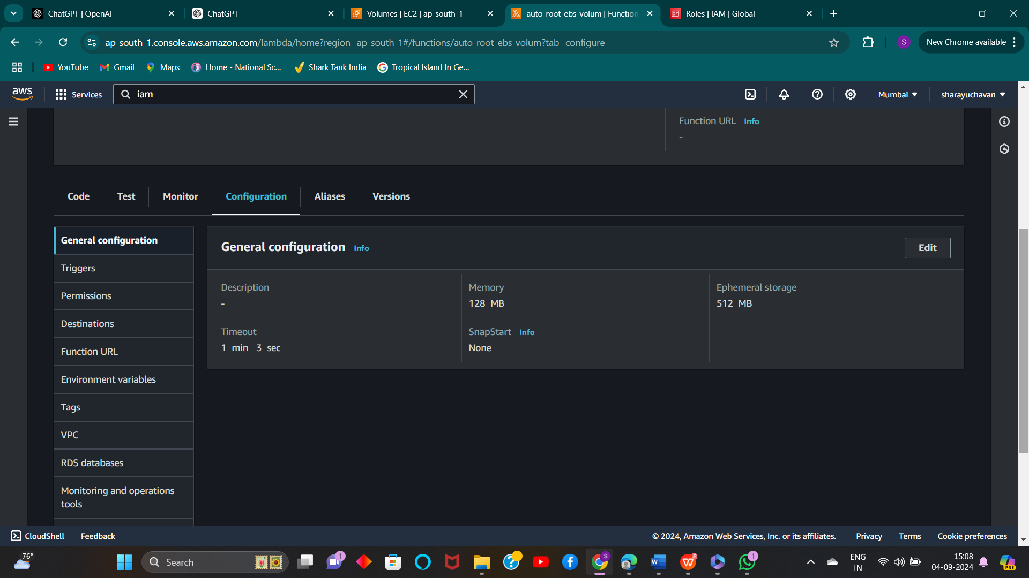

**6) Run the Lambda function manually**

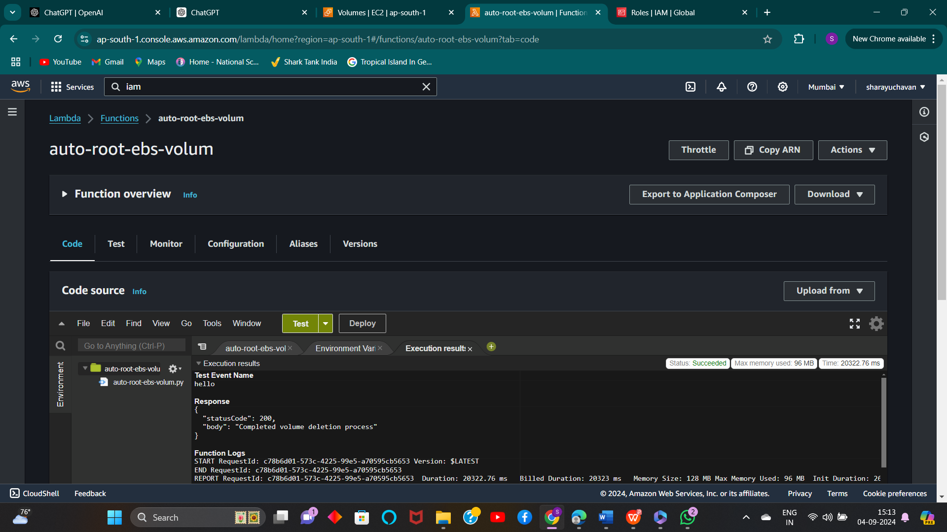

**7) Unused volume deleted successfully.**

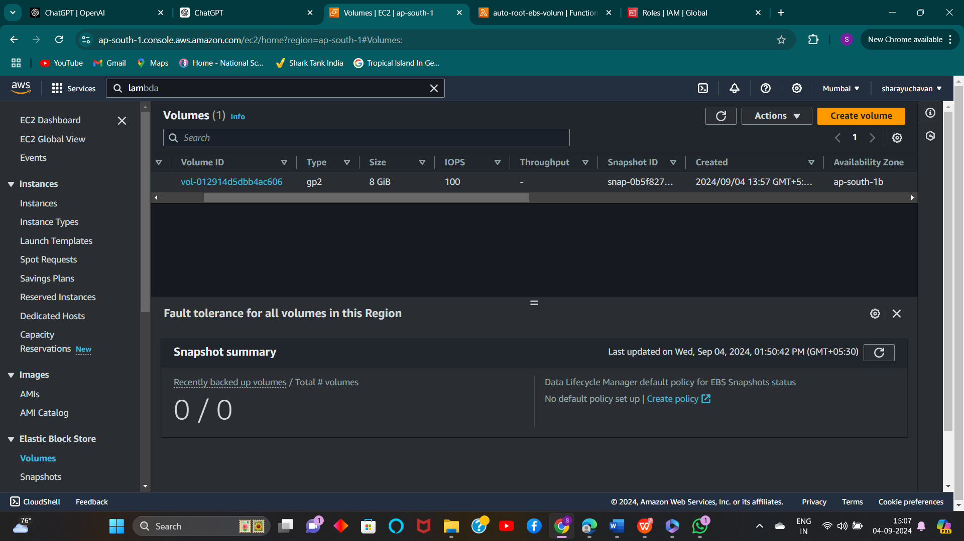

**# Problem Statement-** Create instance using bootstrapping method (add user, groups at the time

creation of instance.)

1) 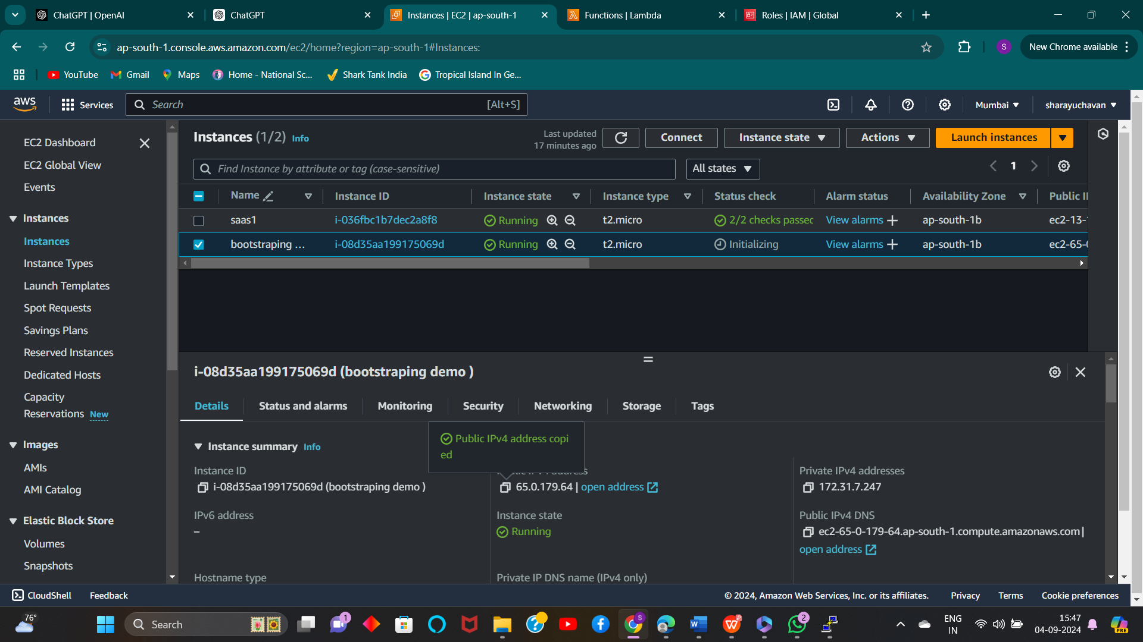

2) **Use below code for bootstrapping at time of creating new instance.**

#!/bin/bash

Adduser tanushree

Adduser sharayu

yum install -y telnet

yum install -y httpd

3) **Connected the Boot Strapping**

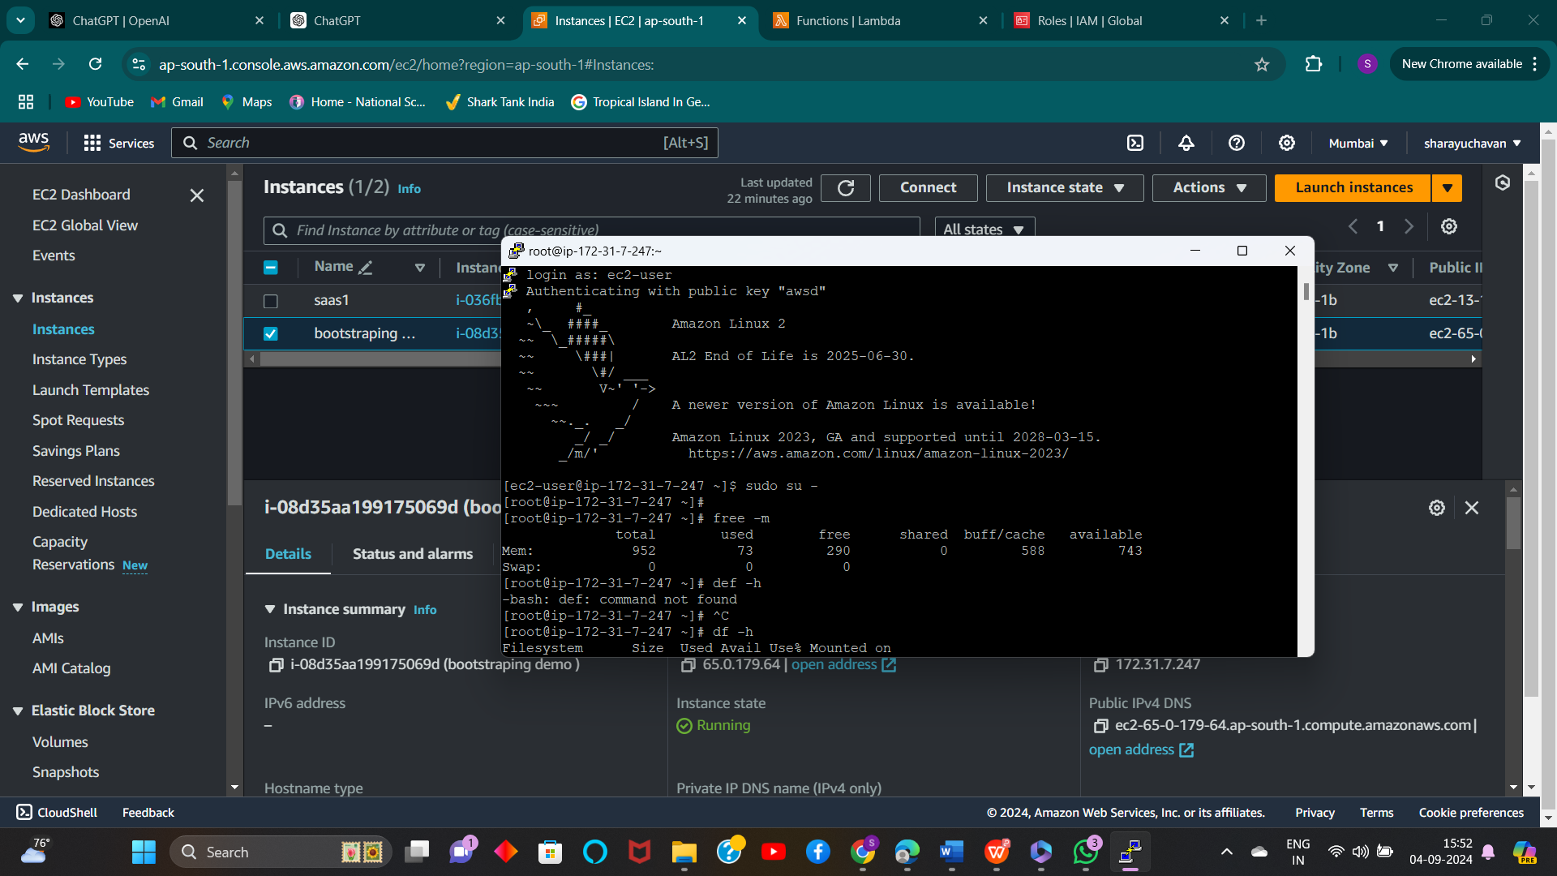

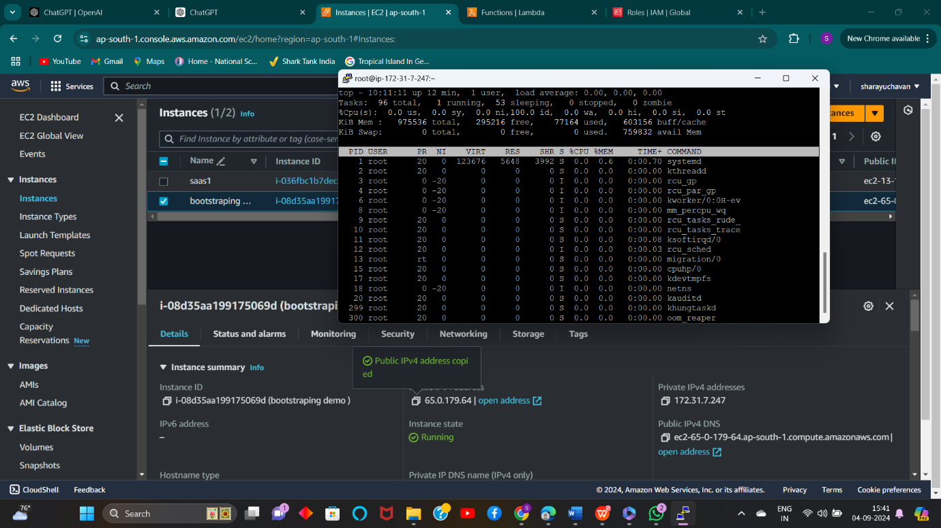

4) **Check the users are created or not**

